OOSE Lab Week 4

Contents

1 Create a Class diagram 1

Week 4

# Create a sequence diagram to illustrate the story of the three little pigs

Create a Sequence diagram using visual paradigm (or other tool).

The sequence diagram should capture the story of the three little pigs:

See: [https://en.wikipedia.org/wiki/The_Three_Little_Pigs#Traditional_versions](https://en.wikipedia.org/wiki/The_Three_Little_Pigs%23Traditional_versions)

The objects to be included in the diagram should be the following:

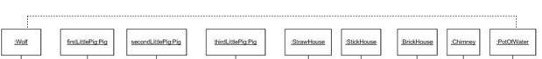

Note that for this diagram we won’t have any explicit actors – the wolf and three little pigs will be considered as objects.